**Screen Shots for HW Week 2 – by Rebecca Cate**

**Worksheet 2014:**

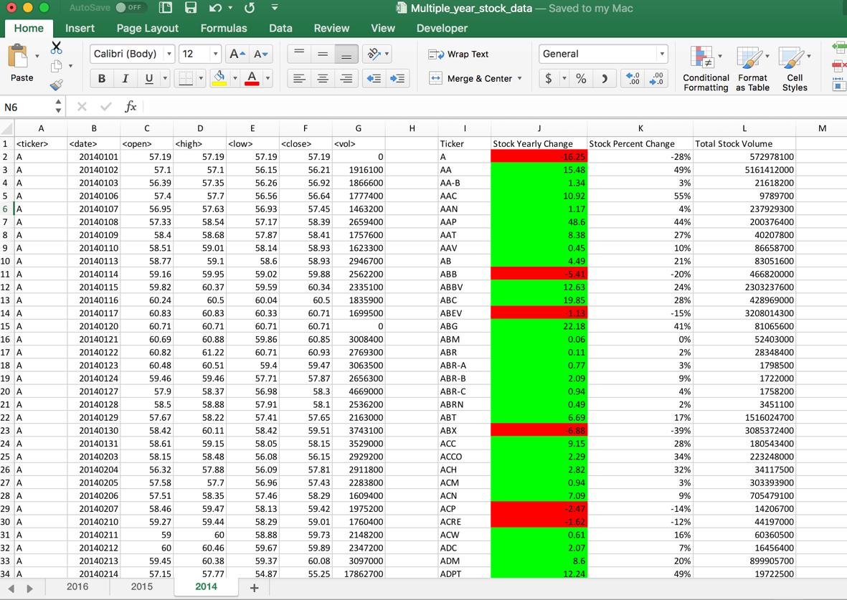

**Worksheet 2015:**

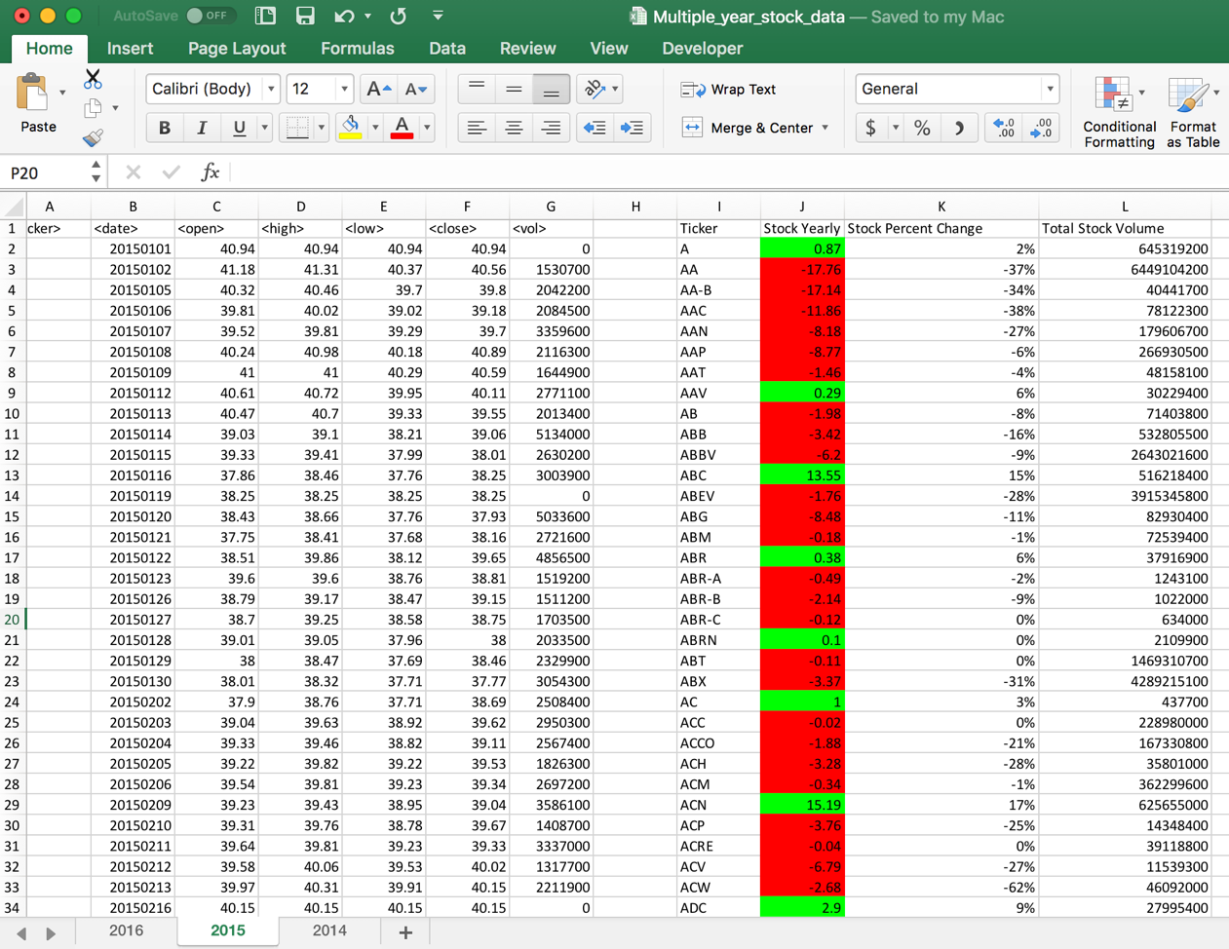

**Worksheet 2016:**

